**HOW TO BUILD METAVERSE WITH THE BEST AND LATEST FEATURES**

The most we could do a little over ten years ago was to make calls and maintain contact. However, as technology advanced, we had the convenience of video calling, which is currently our finest option for staying in touch with our loved ones. Despite how accommodating video chatting is, one still feels let down because technology cannot replace in-person meetings. But what if a technological advancement made it possible for you to attend that event? not only attend, but engage with the guests, mingle, and relive the event as if you were there in person? A decade ago, this scenario would have been dismissed as science fiction fantasy. However, this technology is now referred to as Metaverse.

**History and Evolution of the Metaverse**

The term "metaverse" combines two terms. The Greek term "Meta" denotes beyond, while "Verse" stands for the cosmos. The metaverse is a communal virtual environment where individuals may connect with one another through virtual avatars. Virtual reality, augmented reality, artificial intelligence, NFT technologies, blockchain, and other technologies were used to construct this 3D environment within computers. This immersive technology transports users into a virtual, augmented world where they may experience and carry out a wide range of tasks including shopping, playing games, attending a business conference, staging fashion displays, conducting business, exploring the area, and so forth.

**How to create a metaverse platform of your own**

Now that we are aware of what a metaverse is, how important it is to web 3.0, and the technologies needed to create a metaverse platform. It's time to go more deeply and comprehend what goes into making such an immersive universe.

The stages to creating your metaverse platform are as follows:

**Creating and building a reliable metaverse platform**

The important next few phases entail designing and creating a platform based on the chosen use case. The processes for creating a metaverse platform are listed below.

Prior to appointing the necessary expertise, do market research, analyse industry trends, and focus on end users. The project managers and the core team then conduct an analysis of the data gathered to identify the technologies needed for the project's implementation.

**Select your preferred metaverse platforms and use cases.**

The initial step is to select the right metaverse platform, in which case you may pick whether to build a space or an app. The choice of a use case comes after the platform has been made. There is a plethora of existing metaverse systems, including markets, interactive games, trading in real estate, virtual travel, offices, fashion, education, and others. However, you may choose already-occupied niches or choose to build a metaverse platform with a fresh use case, like the planned 2022 silks project.

**Hiring metaverse experts:**

Because metaverse is still a developing technology, creating an interactive 3D platform requires the expertise of technical experts. For instance, JavaScript-capable programmers are needed to create AR and VR-based apps. Similar to how you would need blockchain specialists and NFT developers for NFT metaverse initiatives. In order to build a user interface, you must engage UI/UX designers.

**Blockchain selection:**

There are a number of blockchains available for metaverse platform creation, including the enduring Ethereum and the more recently established Solana and Polygon. Pick a blockchain that will work best for your project.

**Metaverse smart contract coding:**

The following phase entails creating a smart contract, which is any pre-existing agreement to enable or construct a decentralized metaverse capability. In order to create smart contracts, token standards like ERC-721 and ERC-1155 are utilized.

* **The creation of an IPFS storage system**
* **Building a database to store information**
* **Building the foundation and architecture for the cloud**

Testing the finished product is the following phase, which is done by quality analysts. Their duties include finding and fixing problems as well as inspecting the dependability, technical compliance, and features and functionality of the finished product.

**The beta version is being deployed:**

Deploying the bug-free beta version to cloud servers is the last step. The produced app for mobile apps is made available through mobile app shops like Google Play, Apple Store, Amazon Store, etc.

**Post-launch support system:**

Finishing the designed metaverse project by simply launching it is not the goal. Due to the intricacy of the project, the platform continues to go through a number of test runs. At this point, the project is tested for user response and potential application additions or deletions. The support system also gathers helpful comments to improve and make the platform more user-friendly.

**Conclusion**

You can now fully immerse yourself in many elements of the present metaverse, even though a fully-fledged metaverse might not appear for some years. In the metaverse, anything is possible, whether you choose to play video games with your friends, attend a virtual birthday party, or purchase virtual real estate. Thousands of visitors and numerous multinational companies will be able to take part in virtual fashion displays, witness live musical performances, and buy and wear digital things right from catwalk avatars. Even while it could seem that the phrase "metaverse" is overused and being advocated by zealots, it has the potential to greatly enhance relationships and experiences in life outside of the confines of space and time. The metaverse probably has something related to your area of interest. After all, there are endless chances in a virtual world.

**Grammarly screenshot:**

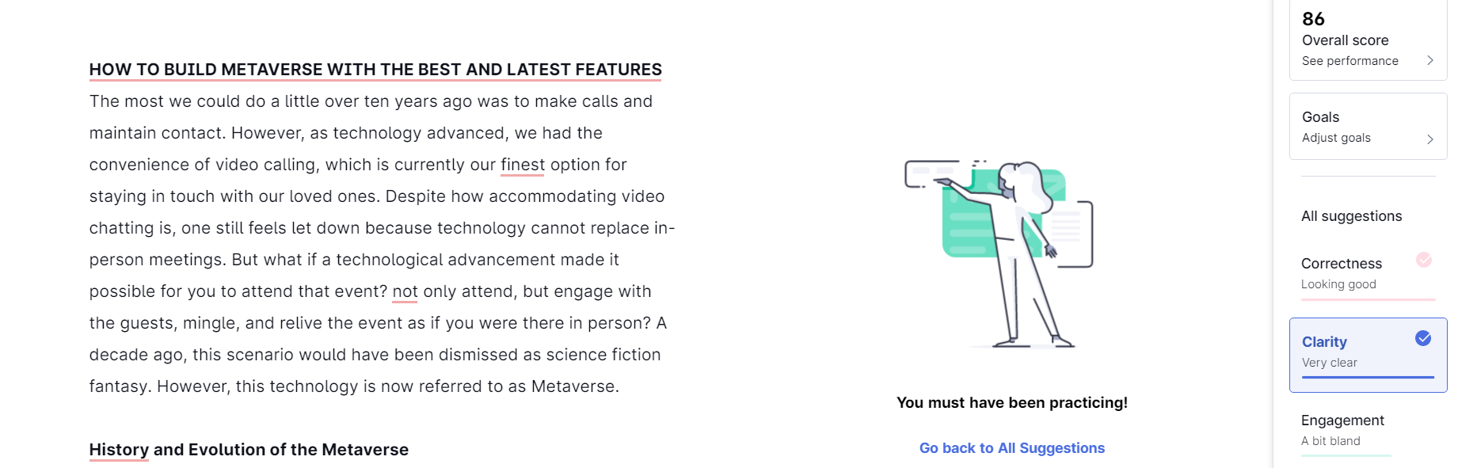

**Plagiarism Checker Screenshot:**

